# Data Structures and Algorithms(UCS540)

Sixth-Semester

Submitted by:

Naman Sood [102104012] 3EE2

BE Third Year (2021-2025) Electrical Engineering

Submitted To: Dr. Yadvendra Singh

Assistant Professor



Department of Electrical & Instrumentation Engineering,

Thapar Institute of Engineering & Technology, Patiala

January-May 2024

# List of Experiments

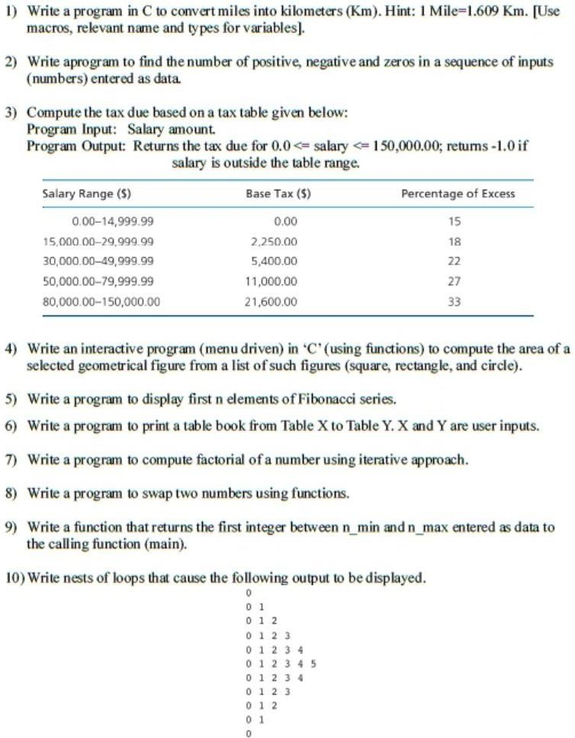

**Q1.**

#include <stdio.h>

#define MILES_TO_KM 1.609

int main() {

double miles, kilometers;

printf("Enter distance in miles: ");

scanf("%lf", &miles);

kilometers = miles * MILES_TO_KM;

printf("%.2f miles is equal to %.2f kilometers\n", miles, kilometers);

return 0;

}

**Output:**

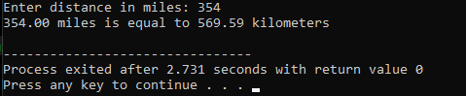

**Q2.**

#include <stdio.h>

int main() {

int num, positiveCount = 0, negativeCount = 0, zeroCount = 0;

char choice;

do {

printf("Enter a number: ");

scanf("%d", &num);

if (num > 0) {

positiveCount++;

} else if (num < 0) {

negativeCount++;

} else {

zeroCount++;

}

printf("Do you want to enter another number? (y/n): ");

scanf(" %c", &choice);

} while (choice == 'y' || choice == 'Y');

printf("\nNumber of positive numbers: %d\n", positiveCount);

printf("Number of negative numbers: %d\n", negativeCount);

printf("Number of zeros: %d\n", zeroCount);

return 0;

}

**Output:**

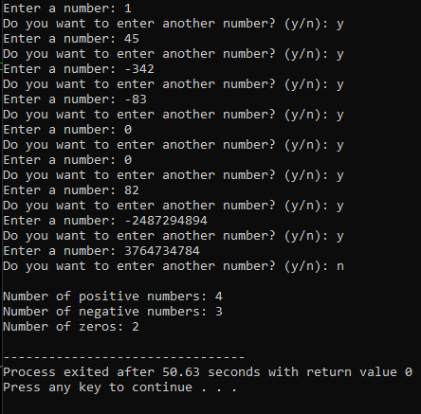

**Q3.**

#include<stdio.h>

int main()

{

float salary;

printf("Input the salary: ");

scanf("%f",&salary);

float amount;

if(salary>0 && salary<=15000)

{

amount = salary + 0.15*salary;

}

else if(salary>15000 && salary<30000)

{

amount = salary + 2250 + 0.18*salary;

}

else if(salary>30000 && salary<50000)

{

amount = salary + 5400 + 0.22*salary;

}

else if(salary>50000 && salary<80000)

{

amount = salary + 11000 + 0.27*salary;

}

else if(salary>80000 && salary<150000)

{

amount = salary + 11000 + 0.33*salary;

}

else

{

printf("Salary out of range");

return -1;

}

printf("Amount:%.2f",amount);

return 0;

}

**Output:**

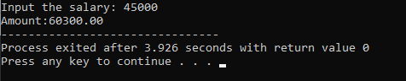

**Q4.**

#include <stdio.h>

#include <math.h>

void displayMenu();

float calculateSquareArea(float side);

float calculateRectangleArea(float length, float width);

float calculateCircleArea(float radius);

int main() {

int choice;

do {

displayMenu();

printf("Enter your choice (1-3, 0 to exit): ");

scanf("%d", &choice);

switch (choice) {

case 1:

{

float side;

printf("Enter the side length of the square: ");

scanf("%f", &side);

printf("Area of the square: %.2f\n", calculateSquareArea(side));

break;

}

case 2:

{

float length, width;

printf("Enter the length of the rectangle: ");

scanf("%f", &length);

printf("Enter the width of the rectangle: ");

scanf("%f", &width);

printf("Area of the rectangle: %.2f\n", calculateRectangleArea(length, width));

break;

}

case 3:

{

float radius;

printf("Enter the radius of the circle: ");

scanf("%f", &radius);

printf("Area of the circle: %.2f\n", calculateCircleArea(radius));

break;

}

case 0:

printf("Exiting program. Goodbye!\n");

break;

default:

printf("Invalid choice. Please enter a valid option.\n");

}

} while (choice != 0);

return 0;

}

void displayMenu() {

printf("\n*** Geometrical Figure Area Calculator ***\n");

printf("1. Square\n");

printf("2. Rectangle\n");

printf("3. Circle\n");

printf("0. Exit\n");

}

float calculateSquareArea(float side) {

return side * side;

}

float calculateRectangleArea(float length, float width) {

return length * width;

}

float calculateCircleArea(float radius) {

return M_PI * radius * radius;

}

**Output:**

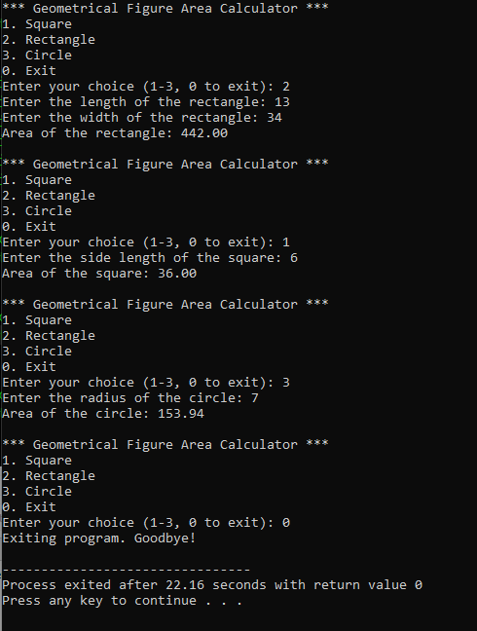

**Q5.**

#include <stdio.h>

void displayFibonacci(int n);

int main() {

int n;

printf("Enter the number of elements in the Fibonacci series: ");

scanf("%d", &n);

displayFibonacci(n);

return 0;

}

void displayFibonacci(int n) {

int first = 0, second = 1, next;

printf("Fibonacci Series (first %d elements): ", n);

for (int i = 0; i < n; i++) {

if (i <= 1)

next = i;

else {

next = first + second;

first = second;

second = next;

}

printf("%d ", next);

}

printf("\n");

}

**Output:**

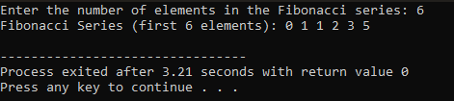

**Q6.**

#include <stdio.h>

void printTable(int start, int end);

int main() {

int x, y;

printf("Enter the starting table number: ");

scanf("%d", &x);

printf("Enter the ending table number: ");

scanf("%d", &y);

printTable(x, y);

return 0;

}

void printTable(int start, int end) {

printf("Table Book from Table %d to Table %d:\n", start, end);

for (int i = 1; i <= 10; i++) {

for (int j = start; j <= end; j++) {

printf("%4d", j * i);

}

printf("\n");

}

}

**Output:**

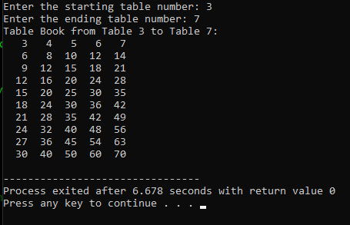

**Q7.**

#include<stdio.h>

int main()

{

int a;

printf("Enter the number for factorial calculation: ");

scanf("%d",&a);

int output = 1;

for(int i = 2; i <= a; i++)

{

output = i*output;

}

printf("Factorial of %d: %d",a,output);

return 0;

}

**Output:**

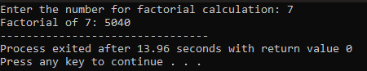

**Q8.**

#include <stdio.h>

void swapNumbers(int *a, int *b);

int main() {

int num1, num2;

printf("Enter the first number: ");

scanf("%d", &num1);

printf("Enter the second number: ");

scanf("%d", &num2);

printf("Original numbers: num1 = %d, num2 = %d\n", num1, num2);

swapNumbers(&num1, &num2);

printf("Numbers after swapping: num1 = %d, num2 = %d\n", num1, num2);

return 0;

}

void swapNumbers(int *a, int *b) {

int temp = *a;

*a = *b;

*b = temp;

}

**Output:**

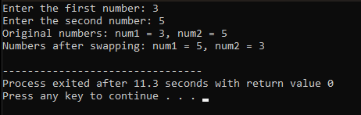

**Q9.**

#include <stdio.h>

int getFirstInteger(int n_min, int n_max);

int main() {

int n_min, n_max;

printf("Enter the minimum value: ");

scanf("%d", &n_min);

printf("Enter the maximum value: ");

scanf("%d", &n_max);

int result = getFirstInteger(n_min, n_max);

if (result != -1) {

printf("The first integer between %d and %d is: %d\n", n_min, n_max, result);

} else {

printf("No integer found between %d and %d\n", n_min, n_max);

}

return 0;

}

int getFirstInteger(int n_min, int n_max) {

for (int i = n_min; i <= n_max; ++i) {

if (i == (int)i) {

return i;

}

}

return -1;

}

**Output:**

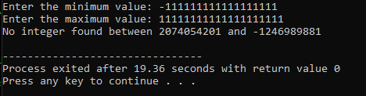

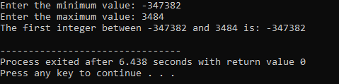

**Q10.**

#include <stdio.h>

int main() {

for (int i = 0; i <= 5; i++) {

for (int j = 0; j <= i; j++) {

printf("%d ", j);

}

printf("\n");

}

for (int i = 4; i >= 0; i--) {

for (int j = 0; j <= i; j++) {

printf("%d ", j);

}

printf("\n");

}

return 0;

}

**Output:**

